Grey highlighting: these are notes, instructions, and examples, remove before submission
Yellow highlighting: complete before submission

Please use this template under a creative commons licence, changing the parts that need to be changed for your local situation. Please do not alter the wordings of the descriptions of peer-reviewed research.

Delegation to <insert name of the group you are addressing here>

Names and roles
<Insert name and roles of the people signing this document here.>

eg,
Dr Jane Doe
Family physician, Springville Family Health Team

John Doe
Parent

<Insert date>

Dear <insert name of the group you are addressing>,

When people look back on these years, one of the things they will find most surprising is that we didn’t protect children. Some data published in late 2022 clarify risk to children and how to protect them. Now is the perfect time to lead our community in this direction.

We will summarize peer-reviewed data on the risk of long COVID in children and adolescents and show, again with peer-reviewed data, the usefulness of mask mandates in schools. It is important to understand the short- and long-term consequences of COVID because of their expected effects on student success and student safety.

Include local information showing that student success and student safety are responsibilities of the group you are addressing. Change the wording if it is different in your source documents. For example:

The HWDSB trustees’ handbook identifies under ‘accountability for student achievement’ – ‘promoting a culture that ensures student success’.

https://www.hwdsb.on.ca/wp-content/uploads/2022/09/Trustee-Policy-Manual-SEPT22-FINAL.pdf

The Education Act (Section 300.0.1 https://www.ontario.ca/laws/statute/90e02) has this language:
1. To create schools in Ontario that are safe, inclusive and accepting of all pupils.
…
6. To provide pupils with a safe learning environment.

Include information on COVID prevalence in your community, usually best shown by death statistics, now that most public health units don’t have a policy of general testing. Write a summary, include a graphic and a link to a public health or government website.

For example:
COVID is highly prevalent at present, best shown by death statistics. The deaths are mostly in older people; I’m not arguing that COVID is directly leading to the death of many children. There were 79 deaths in Ontario in week 46 of 2022, compared with 36 in week 46 of 2022. With respect to COVID, things are worse than they were this time last year.

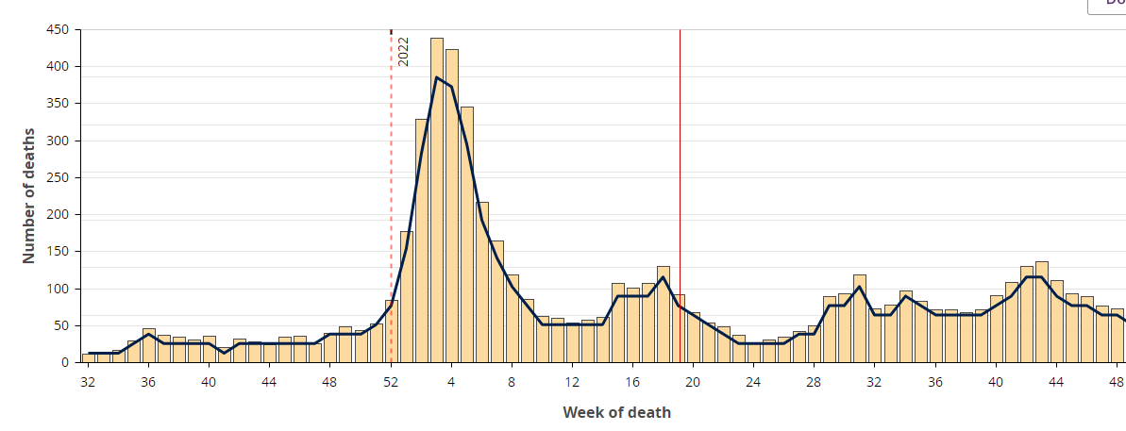

https://www.publichealthontario.ca/en/Data-and-Analysis/Infectious-Disease/COVID-19-Data-Surveillance/COVID-19-Data-Tool?tab=trends

Include information on estimated COVID infections in your community from IHME. IHME uses measured data to estimate the true number of infections occurring in a community.

COVID infections are estimated by the Institute of Health Metrics and Evaluation (IHME) at more than 3 million in Canada for November 2022; compared with 800,000 in Canada in November 2022. Again, so much worse than this time last year.

https://covid19.healthdata.org/canada/ontario?view=mask-use&tab=trend

Is COVID a problem in schools?

COVID is in schools. Not all students who are symptomatic will stay home. Students with known COVID are expected to return to school once they are improving, while still potentially infectious. <Insert local recommendations for self-isolation and masking for symptomatic individuals here, eg, “In some provinces, for example, in Ontario and in Alberta, students whose symptoms are improving are supposed to wear a mask in all public indoor settings until day 10, but this may not be widely known and is unenforceable.” Include the url to the public health or school recommendations.> After COVID, more than 25% of people are still infectious on days 7 to 9.

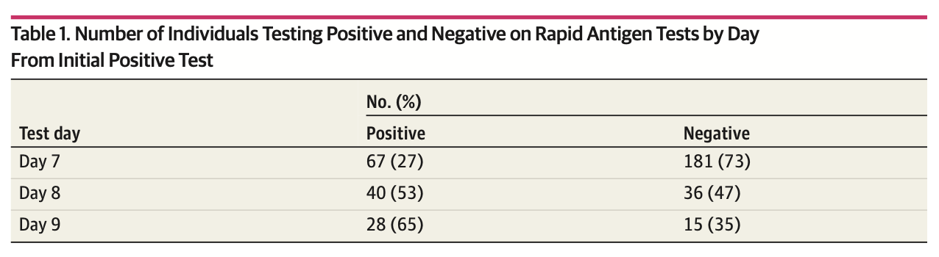

https://jamanetwork.com/journals/jamanetworkopen/fullarticle/2797450

Some students may use rapid tests when symptomatic to help guide their actions. A positive rapid test is still a very useful sign of COVID, but a negative test does not rule it out: 63% of people with Omicron will have a negative rapid test, and 37% a positive test. A negative rapid test in a student with symptoms leads to a false sense of security.

https://covid19-sciencetable.ca/sciencebrief/use-of-rapid-antigen-tests-during-the-omicron-wave/

So COVID is out there in classrooms.

In adults who were vaccinated and had COVID that wasn’t severe, 8% developed long COVID, which is symptoms that persist more than 12 weeks. https://www.nature.com/articles/s41591-022-01840-0

Does COVID hurt children and adolescents? Isn’t it just a cold for them?

Two recent studies show that long COVID is also a serious problem in children:

Published in Nature, 29 November 2022, long COVID was identified in 4% of children and adolescents who had been infected with COVID before Feb 2022. Symptoms included trouble concentrating, headache, nausea, nervousness and fatigue. In other words, 1 in 25 students infected with COVID will suffer long-term consequences to their health, many of them specifically the kinds of problems that interfere with learning.
https://www.nature.com/articles/s41467-022-34616-8

Published in PLOS One, 10 November 2022, the risk of malaise/fatigue/exhaustion was increased by 128% in children and adolescents who had had COVID, compared with those who had not. Adjustment disorder was increased by 71%, headache by 58%, anxiety disorder by 51% and depression by 45%. These figures reflect increases in these problems directly attributable to infection with COVID, and controls for increases in these problems that are part of the societal changes in the pandemic.
https://journals.plos.org/plosmedicine/article?id=10.1371/journal.pmed.1004122

The new finding of long COVID as a common consequence of COVID in children and adolescents means that it is not safe for children, even previously healthy children, to be exposed to COVID at school. The findings of specific problems with fatigue, concentration, headache, and psychiatric problems show that being exposed to COVID at school is likely to interfere with student success.

Student safety and student success are core responsibilities for <insert name of the group you are addressing here>.

Students who are neurodiverse, have sensory processing disorder, or other cognitive disabilities may not be able to wear masks. <Insert your recommendation for how to handle this, eg, They should be exempted from mask wearing - using a ‘no-barrier exemption’ written by a parent. or, eg, They should be medically exempted from mask wearing.> You will be protecting them the best you are able by implementing the use of near-universal masking by other students and staff.

What about harms from mask wearing?

Claims of decompensation from a physiologic or pathologic perspective were quickly shown false. Low oxygen, high carbon dioxide or serious respiratory harms do not occur. A good summary is found here: https://doi.org/10.7326/M20-6625. This paper also shows that some people find wearing masks uncomfortable and that skin irritation and headaches sometimes occur. Note that these effects are related to the wearing of masks and do not persist for 12 weeks or more, unlike the headaches, lack of concentration, and psychiatric syndromes in children who have long COVID.

About problems with social or linguistic development, the American Academy of Pediatrics, on HealthyChildren.org, wrote in August 2021: “While this is a natural concern, there is no known evidence that use of face masks interferes with speech and language development or social communication. Plus, children can still get plenty of face time at home with mask-free family members.”
(https://web.archive.org/web/20220826213955/https://healthychildren.org/English/health-issues/conditions/COVID-19/Pages/Do-face-masks-interfere-with-language-development.aspx. opens in new tab).

The US Centers for Disease Control (CDC) summary identifies no physical or psychological harms. A small proportion of children report irritation, headache, or difficulty breathing in physical education.
https://www.cdc.gov/coronavirus/2019-ncov/science/science-briefs/masking-science-sars-cov2.html

Toddlers, children and adults identify emotion less well when someone is wearing a mask, and the difference is greatest for toddlers, suggesting it is important to have face time at home without masks.
https://doi.org/10.3389/fpsyg.2021.669432

Another study of children 7 – 13 y found that the decrease in ability to read emotions was similar in size to the decrease caused by looking at someone wearing sunglasses.
https://doi.org/10.1371/journal.pone.0243708

Most children have already had COVID. Isn’t it too late?

Second and third infections with COVID are common. While vaccines prevent hospitalization and death, neither prior infection nor vaccination reliably prevents reinfection. Reinfection is actually more common with later variants. https://www.publichealthontario.ca/-/media/Documents/nCoV/voc/2022/10/reinfections-sars-cov2-omicron-variant.pdf?sc_lang=en

Each reinfection carries the same risk of long COVID. https://doi.org/10.1038/s41591-022-02051-3

Do masks work?

Yes, all masks work, some better than others. At the beginning of the pandemic, there was serious scientific debate about this, which is now resolved.

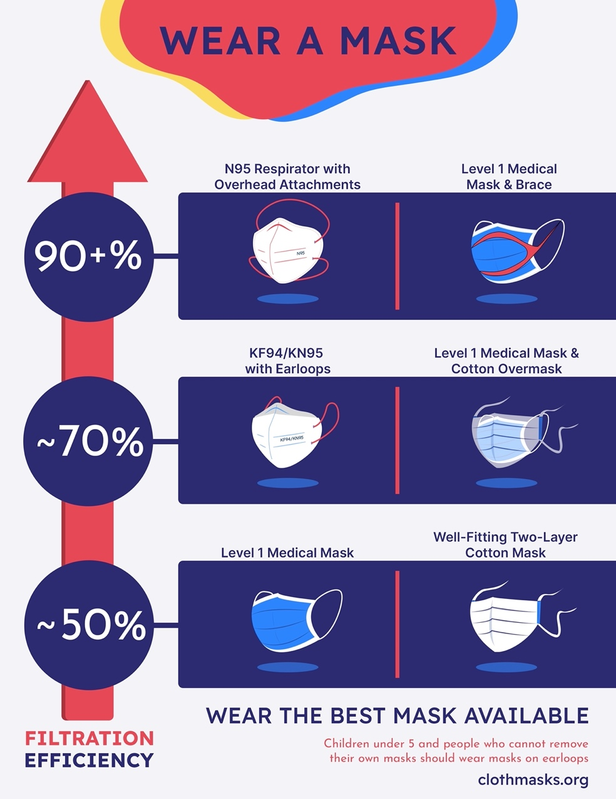

This is an evidence-based infographic on the filtration efficiency of different kinds of masks. This is in the public domain and can be downloaded from https://maskevidence.org/mask-types
- all the references are on that page.

The best way to prevent any kind of pollution is to control it at the source, before the environment is contaminated. This is why we wear masks to prevent our infectious particles reaching the air that others with breath. My mask protects you, your mask protects me. Masks do also protect the wearer, though: the panel above is specifically a summary of studies of protection against tiny (less than one micron) particles reaching human volunteers. My mask protects me, your mask protects you. Masks work best when everyone wears them, which is why we asking for a mandate. Our masks protect us all. This is a great opportunity to teach our children the value of acting societally and protecting everyone. The epidemiology studies backing this up are referenced at https://maskevidence.org/why-masks-matter.

Students can immediately return to wearing the masks they used during mask mandates. Education about which masks are better and promotion of better masks would improve mask efficiency over time. It would also be within the scope of <insert name of the group you are addressing> to petition the <insert name of the level of government that you would suggest asking for this> to provide free better masks to reduce inequities in schools.

Do masks work in schools?

Published in the New England Journal of Medicine, 24 November 2022, direct data show that mask mandates work in schools. In Massachusetts, when the state-wide mask mandate was removed, a number of individual school boards kept theirs, allowing for direct comparisons between boards with an ongoing mask mandate and boards with no mask mandate. Here’s what happened:

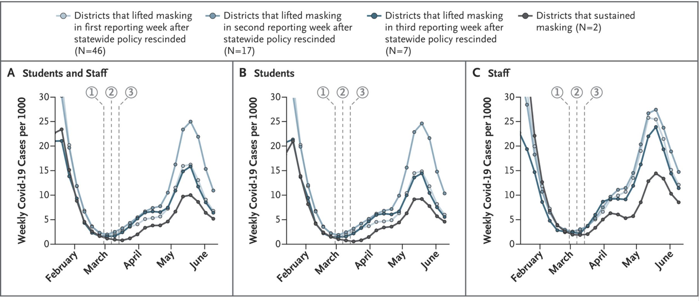

https://www.nejm.org/doi/full/10.1056/NEJMoa2211029

The boards that kept their mask mandates (black line) had much less COVID in the months that followed than those that gave them up (different shades of blue, according to the date their lifted their mandates). Absences among staff and students were much lower. This reinforces the point about student success. Students are more likely to succeed when they, their classmates and their teachers are in school wearing a mask than when they are home with COVID or other respiratory illness.

Isn’t one-way masking enough?

For people at risk one-way masking is not good enough. Even a fit-tested brand-new N95 is only 99% protective. Students do not have access to fit testing, and many do not have access to high-filtration masks.

Without masks, COVID is in many classrooms. No mask will protect students adequately against 35 hours a week of potential exposure.

You do have to choose whether or not to make masks mandatory. Students who can’t wear a mask can be exempted and still attend school safely if a mask mandate is in place; whereas when no mask mandate is in place, students in general, and medically vulnerable students in particular, cannot attend school safely.

You have to choose between two groups of students. When you choose, one group will be disadvantaged. But the harms to the disadvantaged group are not equal or equivalent:

- If you choose a mandate, students who cannot wear a mask are different, and may be disturbed and upset by the appearance of others wearing masks around them. But they are protected from COVID as best they can be, by other people’s masks. And all the other students are as safe as you can make them. There is also the potential to reduce the magnitude of this difference over time because children get used to wearing masks and seeing others in mask. Depending on cognitive abilities, some students will also be able to learn over time that masks are a sign of caring for others.

- If you choose no mandate, students who must wear a mask are different, and may be disturbed and upset by the lack of compassion of those around them - and they are not protected from a disease that could take their life. And all the other students are at risk of educational disruption from sickness, and long COVID.

It is wrong to expose all students to educational disruption and a potentially life-altering illness to normalize the school experience for students who cannot wear a mask.

What is public health’s position?

Many jurisdictions have recommendations or strong recommendations in place at present. Insert the latest advice here. In the US, the CDC is a strong reference.

For example: On 14 November 2022, Ontario’s Chief Medical Officer of Health, Kieran Moore ‘strongly recommended’ that Ontarians mask ‘in all indoor health settings, including schools and childcare’.

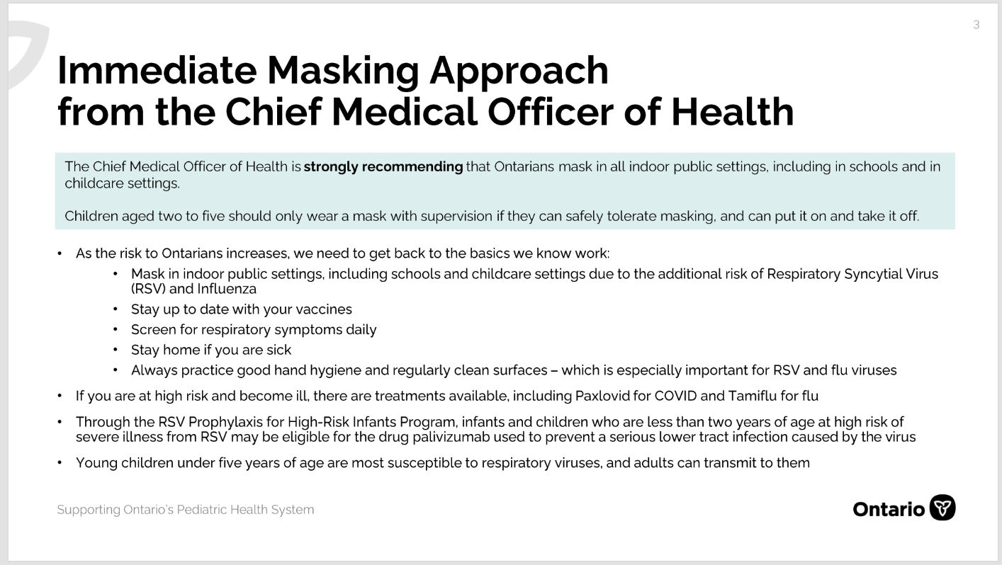

https://www.cbc.ca/news/canada/toronto/ontario-dr-kieran-moore-announcement-1.6650571#presentation

What is the public’s position?

Insert polling for your location. YouGov sometimes has useful polls; others are commissioned by main stream media.

In the US, Data for Progress has useful polling data. https://www.dataforprogress.org/coronavirus

This example is for Canada, late 2022:

In a November 2022 poll conducted by Nanos Research for CTV news, 71% of Ontarians support or strongly support mask mandates, if necessary. We don’t have a mask wearing culture in North America. People know things are bad, they just don’t want to wear a mask if they don’t have to, and if others aren’t. They are waiting for leaders to let them know it’s time. It’s time; you can be those leaders.

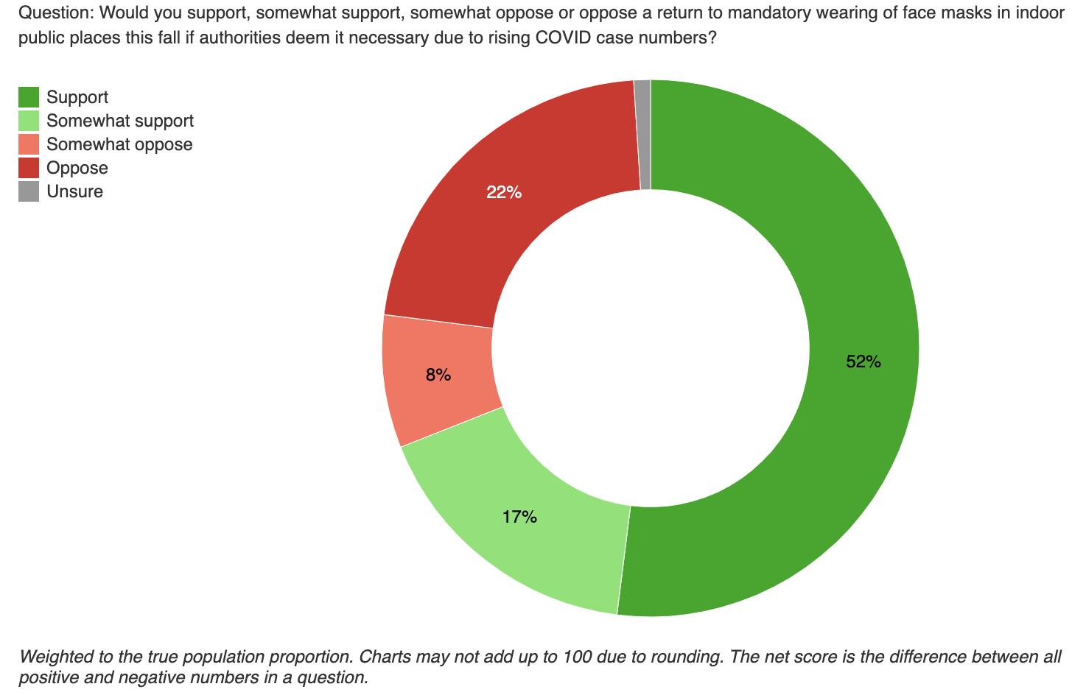

https://www.ctvnews.ca/health/coronavirus/majority-of-canadians-support-return-of-face-masks-in-indoor-public-spaces-if-deemed-necessary-survey-1.6144419

In summary, we have shown that COVID leads to long COVID in 4% of children: this is a threat to student safety. Fatigue and brain-fog as part of long COVID are a threat to student success. We’ve shown that mask mandates in schools reduce transmission in schools, which leads to more staff and students in classrooms, as well as a reduced risk of COVID and long COVID.

Thank you for considering our evidence-based argument.

Respectfully submitted,

<Insert your names again here>

